Plot of detection*count. Legend: A = 1 obs, B = 2 obs, etc.
detection |
39600 + Z
|
|
|
36300 +
| A
| A D
| A D
33000 + D AA D
| A
| C A
| A A
29700 + A A B
| D A
| D D
| P
26400 + D
| DD C D
| AK CD
|
23100 + OL
| D D
| DD
| D
19800 + Y C C D E
| FF I C C
| AFH A D
| ZZA A A D A
16500 + CHD D
| AB B D
| EBB A B HD D DD B
| BCA C B
13200 + AA C D A
| BA D A A
| AD D A D B
| BD DC D D D E
9900 + ZA H
| CJA QN D G D B
| EEA CND D ZJ K C
| G D LZ B A B
6600 + AA D D D DJ A C
| OTB D IDHLL DA A
| A D H B
| OR DAD D Q B
3300 + A DD HL B B
| NL H D A I E
| AEZA A A L
| PLZDHD A D H LQ D X L
0 + ZZ D AAHFFICAE AFFXSRLIEDGNIKE HDDDD H DZZ D IZI D D H H Z
---+------------+------------+------------+------------+------------+------------+------------+------------+--
0 5000 10000 15000 20000 25000 30000 35000 40000
count
NOTE: 3791 obs hidden.

Number of Observations Read | 5410
Number of Observations Used | 5410

Analysis of Variance
Source | DF | Sum of  Squares | Mean  Square | F Value | Pr > F
Model | 1 | 1.160982E11 | 1.160982E11 | 2424.17 | <.0001
Error | 5408 | 2.589992E11 | 47891872
Corrected Total | 5409 | 3.750974E11

Root MSE | 6920.39539 | R-Square | 0.3095
Dependent Mean | 4118.84196 | Adj R-Sq | 0.3094
Coeff Var | 168.01799

Parameter Estimates
Variable | DF | Parameter  Estimate | Standard  Error | t Value | Pr > |t|
Intercept | 1 | 672.03744 | 117.27448 | 5.73 | <.0001
count | 1 | 0.37016 | 0.00752 | 49.24 | <.0001

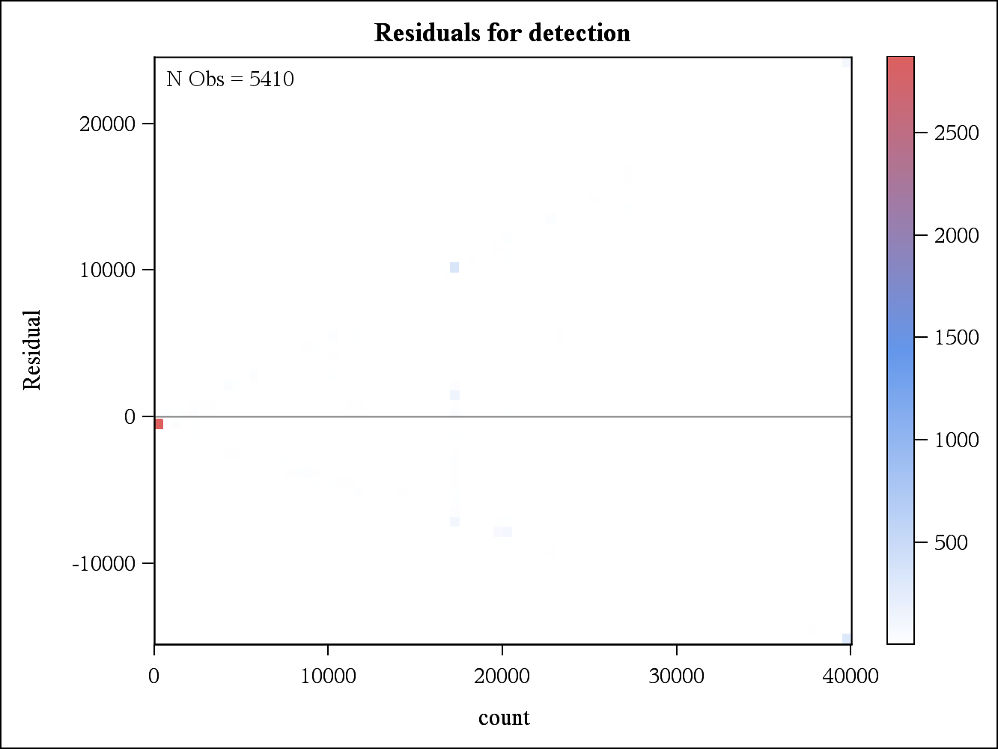

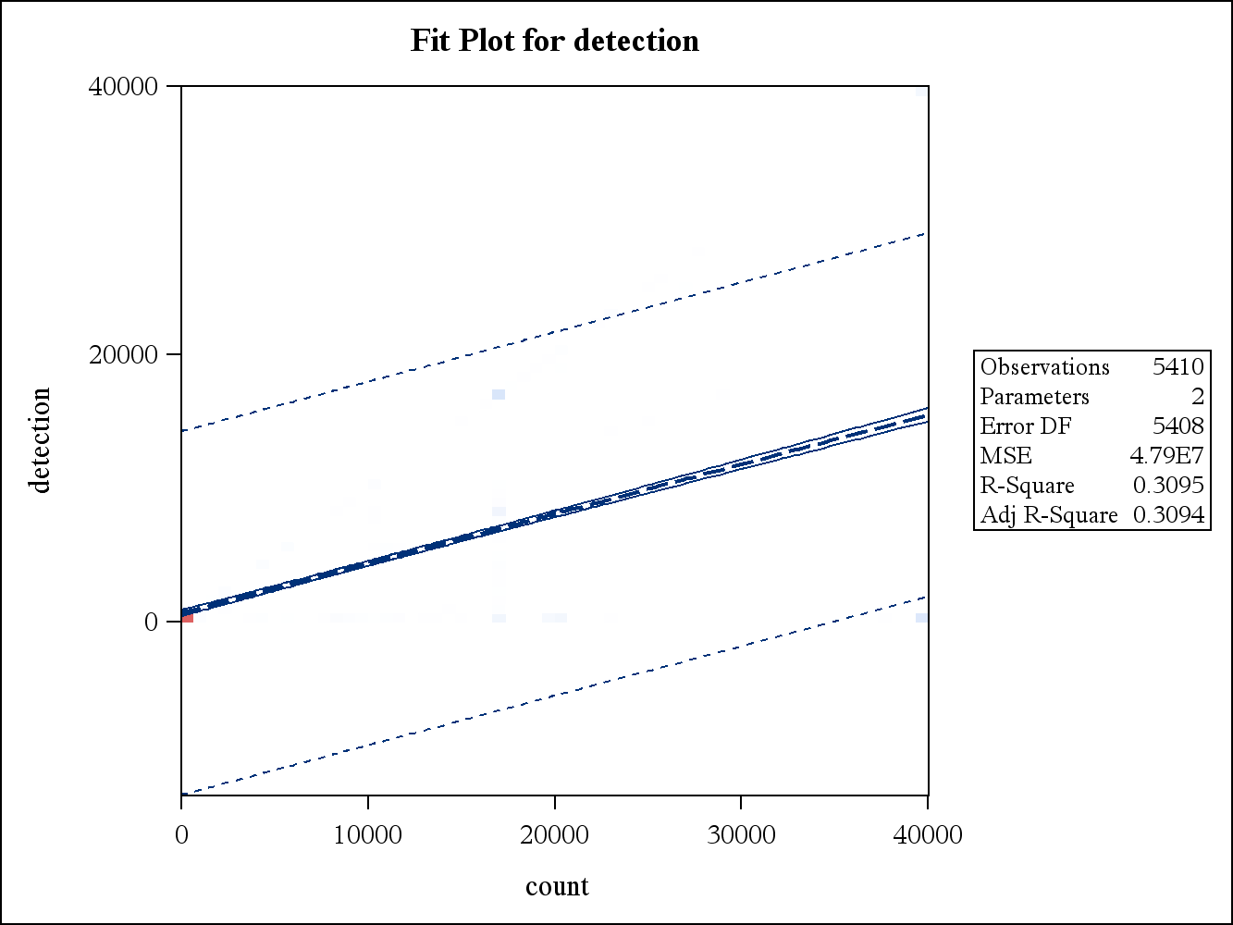
2 Variables: | count detection

Simple Statistics
Variable | N | Mean | Std Dev | Sum | Minimum | Maximum
count | 5410 | 9312 | 12516 | 50376194 | 0 | 40000
detection | 5410 | 4119 | 8327 | 22282935 | 0 | 40000

Pearson Correlation Coefficients, N = 5410
Prob > |r| under H0: Rho=0
 | count | detection
count | 1.00000 | 0.55634  <.0001
detection | 0.55634  <.0001 | 1.00000

